Day 5

*1. GROUP BY with WHERE - Orders by Year and Quarter Display, order year, quarter, order count, avg freight cost only for those orders where freight cost > 100*/

## QUERY:

select * from orders limit 5

select count(*) as order_count, round(avg(freight)::numeric,2) as average_freight_cost, extract(year from order_date) as year, extract(quarter from order_date) as quarter from orders where freight > 100 group by extract(year from order_date), extract(quarter from order_date) order by year,quarter desc

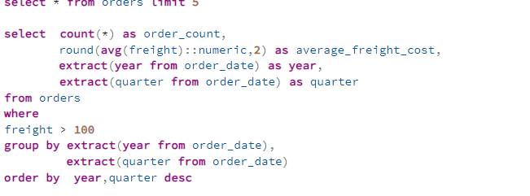Output:

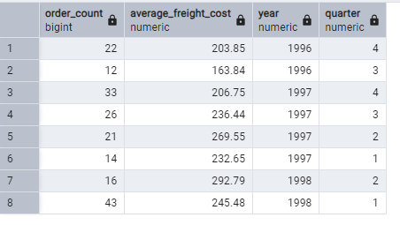

2 GROUP BY with HAVING - High Volume Ship Regions

Display, ship region, no of orders in each region, min and max freight cost

Filter regions where no of orders >= 5

## QUERY:

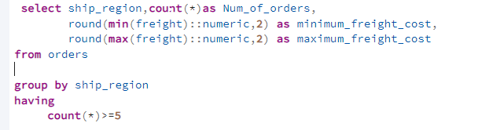Output:

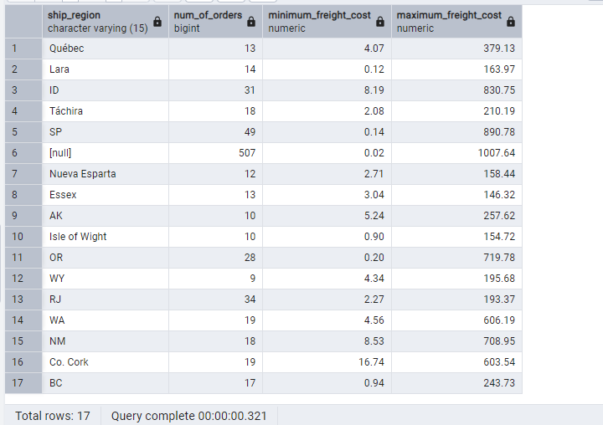

3. Get all title designations across employees and customers ( Try UNION & UNION ALL)

## Query:

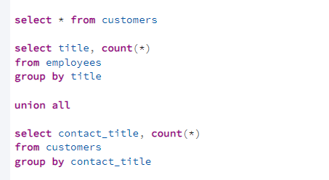

## Output:

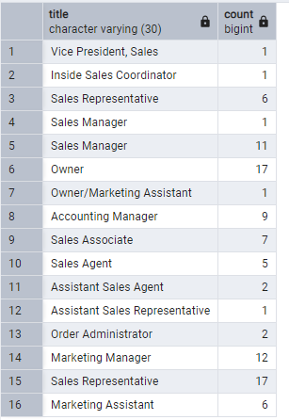

## Union:

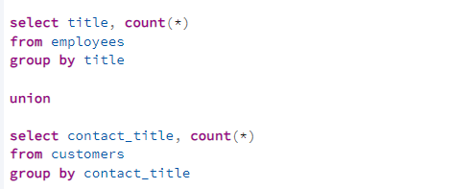

## Output:

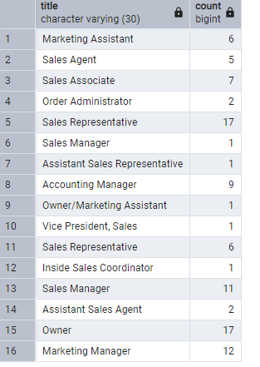

/*4. Find categories that have both discontinued and in-stock products (Display category_id, instock means units_in_stock > 0, Intersect)*/

## Query:

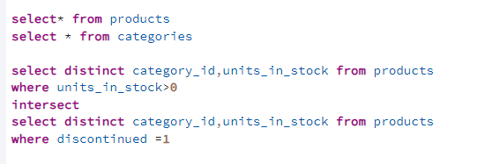

## Output:

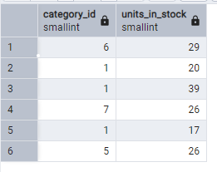

--5.Find orders that have no discounted items (Display the order_id, EXCEPT)

## Query:

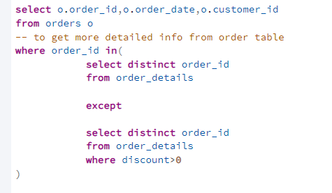

## Output:

